Graphics for Qualitative/Categorical DATA (MOL4)
- Make a Pie Graph using the file imdb_before_color for the variable content_rating which will include:
  - The title “Distribution of Ratings for 26 Movies Before Color” (1 pt)
  - Label to include the rating and percent (2 pt)
  - Copy and paste your code (0.5 pt) and the resultant Pie graph here (0.5 pt):
Results: 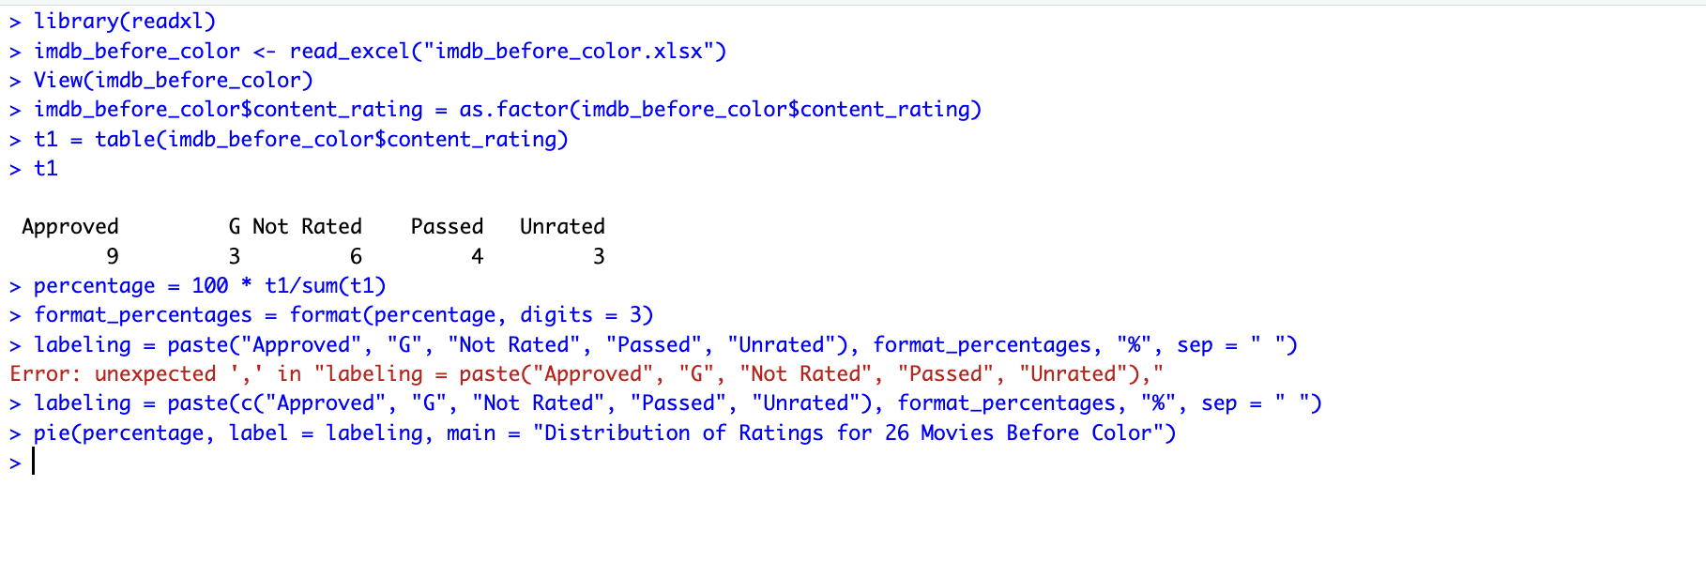 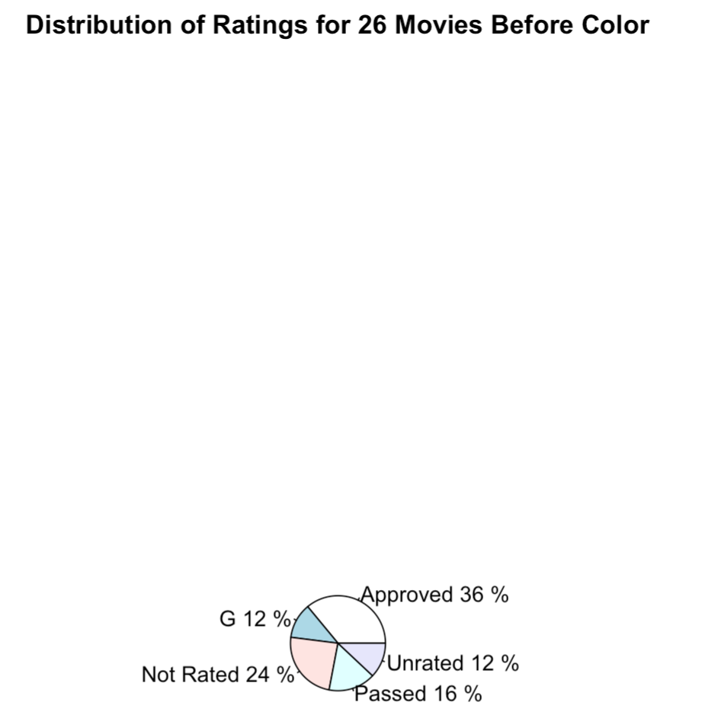

- Make a Frequency Bar Graph using the file imdb_before_color for the variable content_rating which will include:
  - The title “Distribution of Ratings for 26 Movies Before Color” (0.5 pt)
  - X Label to include the rating (0.5 pt)
  - Y Label, “Number of Movies” (0.5 pt)
  - Make the color blues9 (0.5 pt)
  - Copy and paste your code (0.5 pt) and the resultant Frequency Bar graph here (0.5 pt):
Results: 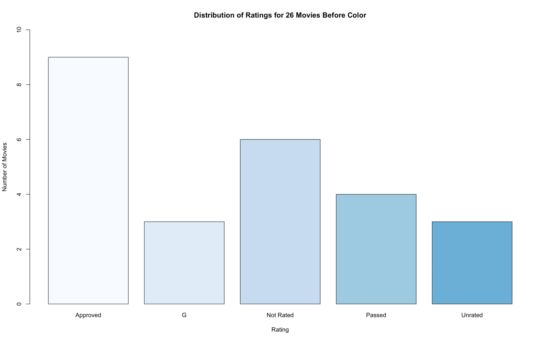

- Make a Relative Frequency Bar Graph using the file imdb_before_color for the variable content_rating which will include:
  - The title “Distribution of Ratings for 26 Movies Before Color” (0.5 pt)
  - X Label to include the rating (0.5 pt)
  - Y Label, “Percent of Movies) (0.5 pt)
  - Make the color blues9 (0.5 pt)
  - Copy and paste your code (0.5 pt) and the resultant Relative Frequency Bar graph here (0.5 pt):
Results: 